# UNMANNED AERIAL VEHICLE FOR CRIME DETECTION AND RESCUE

**(PROJECT PHASE I)**

## A PROJECT REPORT

### Submitted by

**Allwin Meshach Hezron T (310620106012)**

**Bhuvaneshwaran L (310620106021)**

### In partial fulfillment for the award of the degree of

**BACHELOR OF ENGINEERING**

***In***

## ELECTRONICS AND COMMUNICATION ENGINEERING



**EASWARI ENGINEERING COLLEGE, CHENNAI**

## (Autonomous Institution)

### Affiliated to

**ANNA UNIVERSITY**: **CHENNAI - 600025**

**DECEMBER 2023**

# UNMANNED AERIAL VEHICLE FOR CRIME DETECTION AND RESCUE

**(PROJECT PHASE I)**

## A PROJECT REPORT

### Submitted by

**Allwin Meshach Hezron T (310620106012)**

**Bhuvaneshwaran L (310620106021)**

### In partial fulfillment for the award of the degree of

**BACHELOR OF ENGINEERING**

***In***

## ELECTRONICS AND COMMUNICATION ENGINEERING



**EASWARI ENGINEERING COLLEGE, CHENNAI**

## (Autonomous Institution)

### Affiliated to

**ANNA UNIVERSITY**: **CHENNAI - 600025**

**DECEMBER 2023**

# EASWARI ENGINEERING COLLEGE, CHENNAI

**(AUTONOMOUS INSTITUTION) AFFILIATED TO ANNA UNIVERSITY, CHENNAI - 600025**

**BONAFIDE CERTIFICATE**

Certified that this project report **“ARDUINO-BASED HUMAN TRACKING ROBOT IN THE COLLAPSED BUILDING USING IOT”** is the bonafide work of **“Allwin Meshach Hezron T (310620106012) Bhuvaneshwaran L (310620106021)”** who carried out the project work under my supervision.

**SIGNATURE SIGNATURE**

**Dr. M. DEVARAJU Ms.Suruthi S**

**HEAD OF THE DEPARTMENT**

Professor Assistant Professor

Department of Electronics and Department of Electronics and

Communication Engineering Communication Engineering

Easwari Engineering College Easwari Engineering College

Ramapuram, Chennai 600089 Ramapuram, Chennai 600089



Submitted for Semester Examination held on _

## INTERNAL EXAMINER EXTERNAL EXAMINER

# ACKNOWLEDGEMENT

We are indebted to many people who helped us to complete our project and assisted us since the inception of the idea till the day we documented it and even after that. Firstly, we would like to express our gratitude to **Dr. T R PAARIVENDHAR,** Founder Chairman, SRM Group of Institutions, without whose support our project could not have been completed successfully.

We would also like to thank **Dr. R SHIVA KUMAR, M. D Ph.D., Chairman, SRM Group of Institutions, Ramapuram Campus** for providing us with the required assistance and **Dr. R.S. KUMAR, Principal, Easwari Engineering College** for his continuous encouragement that led us to where we are right now, satisfied, having gotten what we had worked for.

We are very much grateful to **Dr. M DEVARAJU, Head of the Department, Electronics and Communication Engineering** for helping us with our attendance and providing continuous encouragement for the completion of the project.

We take the extreme privilege of extending our hearty thanks and sincere gratitude to **NAME, Associate Professor, Project Coordinator, Electronics and Communication Engineering,** for her suggestions, support, and encouragement towards the completion of the project with perfection.

We are thankful to our supervisor **Name, Associate professor, Electronics and Communication Engineering**, for intellectual guidance and valuable suggestions in making this project a successful one.

We would extend our hearty thanks to all our panel members for their guidance and suggestions in completing this project.

**Allwin Meshach Hezron T**

**Bhuvaneshwaran L**

# ABSTRACT

This innovative autonomous drone system is designed for versatile search, surveillance, and response operations, featuring two specialized modes. In Mode 1, the drone functions as a vigilant security patrol vehicle, constantly monitoring designated areas using GPS coordinates, enhancing security measures and minimizing risks to human personnel. Mode 2 harnesses advanced computer vision and facial recognition algorithms to locate and track individuals within specific zones, providing real-time data to ground teams, significantly improving search and rescue missions and security operations. Key components, such as the Flight Controller, Raspberry Pi, Arducam Camera, Battery, and Battery Management System, ensure system stability, data processing, and efficient power management. This autonomous drone system revolutionizes crime detection and response, offering rapid, informed, and proactive capabilities. It plays a pivotal role in search operations, damage assessment, and surveillance, ultimately contributing to public safety, preserving lives, and safeguarding property. Responsible application, adherence to regulations, privacy concerns, and professional training are vital considerations in deploying this technology effectively. The continuous evolution of drone technology enhances its effectiveness in addressing complex challenges in various domains.

|  | TABLE OF CONTENTS |  |
| --- | --- | --- |
| **CHAPTER** | **TITLE** | **PAGE NO** |
| **NO.** |  |  |
|  | **ABSTRACT** |  |
|  | **LIST OF FIGURES** |  |
|  | **LIST OF ABBREVIATIONS** |  |
| **1** | **INTRODUCTION** | 11 |
|  | 1.1 General Overview | 11 |
|  | 1.2 Scope of the Project | 12 |
| **2** | **LITERATURE REVIEW** | 13 |
| **3** | **SYSTEM IMPLEMENTATION** | 15 |
|  | * 1. Block diagram   2. Block diagram description   3.21 Raspberry Pi 3 | 15  16  16 |
| **4** | * 1. Arducam Camera   2. BLDC Motor   3. ESC simonk 30A   4. Flight controller Multiwii cruise   5. Li-Po battery pack   **SOFTWARE IMPLEMENTATION**   * 1. NodeJS   2. React JS   3. Mysql   4. Python   5. Flow chart | 19  20  22  26  26  13  13  13  28  30  30 |

1. **PROPOSED METHODOLOGY** 30
   1. Proposed methodology 30
2. **RESULTS AND DISCUSSION** 31
   1. Results and discussion 31
3. **CONCLUSION** 33

**REFERENCES** 34

# LIST OF TABLES

| **S. NO** | **FIGURE NO** | **TITLES** | **PAGE. NO** |
| --- | --- | --- | --- |
| 1 | 3.1 | Block diagram of the proposed system | 13 |
| 2 | 3.211 | Raspberry Pi 3 | 15 |
| 3 | 3.212 | Raspberry Pi 3 Pinout | 16 |
| 4 | 3.221 | Arducam Camera | 17 |
| 5 | 3.231 | BLDC motor | 18 |
| 6 | 3.241 | ESC wiring configuration | 18 |
| 7 | 3.242 | OUTPUT OF ESC | 19 |
| 8 | 3.261 | Lipo battery pack | 20 |
| 9 | 4.5 | Flow chart | 36 |

| LIST OF ABBREVIATIONS | |
| --- | --- |
| **ABBREVIATIONS** | **EXPLANATIONS** |
|  |  |
|  |  |
|  |  |
|  |  |
|  |  |
|  |  |
|  |  |
|  |  |

|  |  |
| --- | --- |
|  |  |
|  |  |

# CHAPTER I INTRODUCTION

### 1.1 General Overview

This project introduces a specialized application of unmanned aerial vehicles (UAVs) dedicated to responsive zone surveillance in emergency scenarios. The system is activated upon the user's pressing of an SOS button, signaling the UAV to initiate high-quality video capture and transmission within the designated area of concern.Designed explicitly for surveillance purposes, these UAVs swiftly mobilize upon SOS activation, deploying advanced imaging technology to capture real-time video footage of the targeted zone. The system transmits this footage to a centralized server or designated receivers, providing crucial visual data to responders or relevant authorities. The core functionality of these UAVs revolves around their ability to perform rapid and precise zone surveillance. By leveraging their high-fidelity video capabilities, they serve as proactive surveillance platforms, aiding in situational assessment and decision-making processes during emergencies.

In this innovative project, the focus lies on leveraging cutting-edge technology to enhance security. A crucial component is the integration of an imaging sensor, which passively monitors the surroundings, aiding in identifying human presence within the zone. The sensor interfaces with a single board computer, facilitating the collection and processing of visual data.The robotic chassis incorporates a ECU and a BLDC motor enabling seamless navigation through challenging areas. To facilitate comprehensive surveillance, Arducam camera with a 180-degree fov,.The Arducam camera plays a pivotal role in live streaming human movements within the zone, utilizing a local host setup complete with an assigned IP address. This live stream enables real-time data transmission across networks without requiring manual intervention.

### 1.2 Scope of the Project

Advancements in human-searching robotics have shown significant progress, yet widespread adoption hinges on durability and user-friendliness enhancements. Diverse threats globally, spanning from crimes impacting public safety to those affecting national economies, underscore the urgency for more robust solutions. Current research predominantly centers on single-platform deployment for search robots. However, as these robots transition from controlled environments to real-world applications with distinct environmental demands, the future trend leans towards multi-agent networks and technology integration. This evolution anticipates a reduction in response times during critical crime scenarios. The amalgamation of various technologies within search and rescue robots stands poised to mitigate risks to human life, marking a pivotal shift in optimizing crisis management protocols.

# CHAPTER II

## 2.1 LITERATURE REVIEW

| **S.NO** | **Journal Details** | **Techniques used** | **Inference** |
| --- | --- | --- | --- |
| 1. | Y. Pan, Q. Chen, N. Zhang, Z. Li, T. Zhu and Q. Han,  "Extending Delivery Range and Decelerating Battery Aging of Logistics UAVs Using Public Buses," in IEEE Transactions on Mobile Computing, vol. 22, no. 9, pp. 5280-5295, 1 Sep. 2023, doi: 10.1109/TMC.2022.3167040. | ULRB framework | Extending the monitoring time and reduces the battery usage of the UAV using Public Buses |
| 2. | Y. Zeng, X. Xu, S. Jin and R. Zhang,  "Simultaneous Navigation and Radio Mapping for Cellular-Connected UAV With Deep Reinforcement Learning," in IEEE Transactions on Wireless Communications, vol. 20, no. 7, pp. 4205-4220, July 2021, doi: 10.1109/TWC.2021.3056573. | Coverage-aware navigation | UAVs controllable mobility to design its navigation/trajectory to avoid the cellular coverage holes while accomplishing their missions |

| **S.NO** | **Journal Details** | **Techniques used** | **Inference** |
| --- | --- | --- | --- |
| 3. | J. Yoon, A. -H. Lee and H. Lee,  "Rendezvous: Opportunistic Data Delivery to Mobile Users by UAVs Through Target Trajectory Prediction," in IEEE Transactions on Vehicular Technology, vol. 69, no. 2, pp. 2230-2245, Feb. 2020, doi: 10.1109/TVT.2019.2962391. | Trajectory prediction, Path planning | UAV perform their own distributed path planning collaboratively over time |
| 4. | S. Zahran, A. M. Moussa, A. B. Sesay and N. El-Sheimy,  "A New Velocity Meter Based on Hall Effect Sensors for UAV Indoor Navigation," in IEEE Sensors Journal, vol. 19, no. 8, pp. 3067-3076, 15 April 15, 2019, doi: 10.1109/JSEN.2018.2890094. | (INS) Inertial navigation systems | UAVs became more capable of fulfilling their tasks without any human intervention, by depending on the fusion of its onboard sensors to navigate autonomously |
| 5. | Pooja P. P, Rekha K. S, “Design and implementation of alive human detection robot”, IJSRD - International Journal for Scientific Research & Development, Volume 6, Issue 03, 2018 | PIR Sensor, Rescue Robot, Microcontroller | This system uses a specific set of sensors that includes PIR, temperature, vibration, IR, Ultrasonic detector, etc. which gives information about an alive human body. GSM technology is used which gives an alerting message to the control room of the affected site. |

# CHAPTER III SYSTEM IMPLEMENTATION

## 3.1 Block diagram

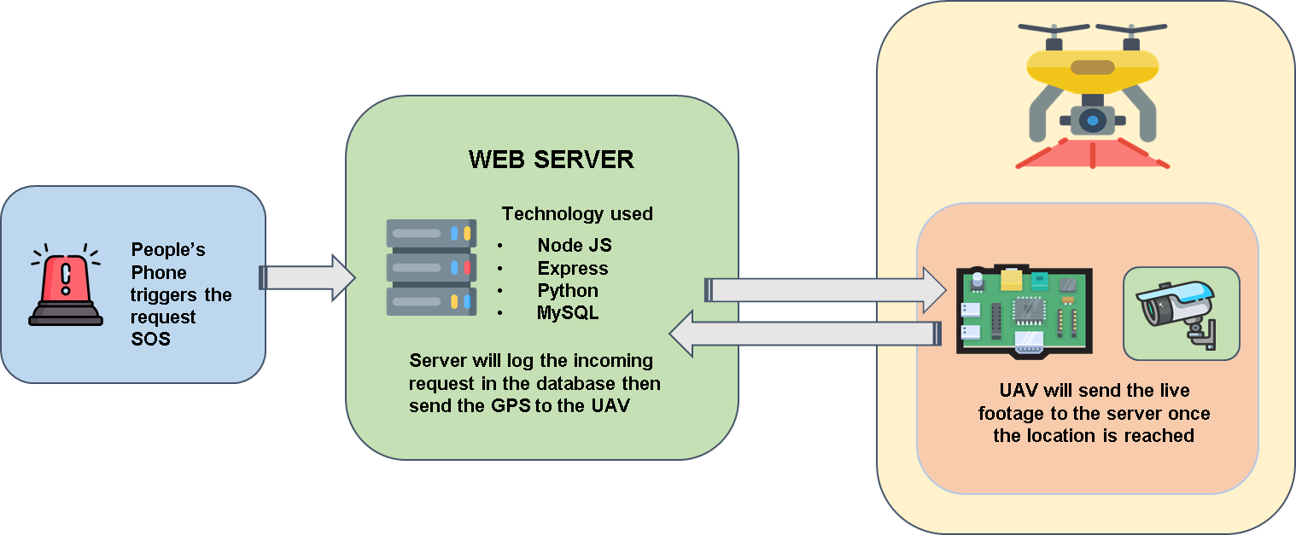

**Fig 3.1 Block diagram of the proposed system**

## 3.2 Block diagram description

The project “UNMANNED AERIAL VEHICLE FOR CRIME DETECTION AND RESCUE” consists mainly of the following blocks.

* + - Raspberry pi 3
    - Arducam Camera
    - Li-Po battery pack
    - Flight controller Multiwii cruise SE 2.5
    - BLDC motor
    - ESC simonK 30A

### 3.21 Raspberry Pi 3

The Raspberry Pi 3 stands as the core component of the system, functioning as a versatile microcomputer with a broad array of capabilities. It encompasses the following features.

#### Specifications:

* Processor – Broadcom BCM2837
* Operating Voltage – 5V
* Input Voltage – 5V via Micro USB or GPIO header
* GPIO Pins – 40 (General Purpose Input/Output)
* PWM Pins – 15
* Analog Input Pins – None (Can use external ADC for analog input)
* RAM – 1GB
* Flash Memory – MicroSD card slot for storage
* USB Ports – 4 x USB 2.0
* Ethernet Port – 10/100 Mbps Ethernet
* Wireless Connectivity – Wi-Fi 802.11n, Bluetooth 4.2
* HDMI Port – Full-sized HDMI output
* Audio – 3.5mm audio jack, HDMI audio output
* Clock Speed – 1.2 GHz
* Built-in LED – Power indicator LED

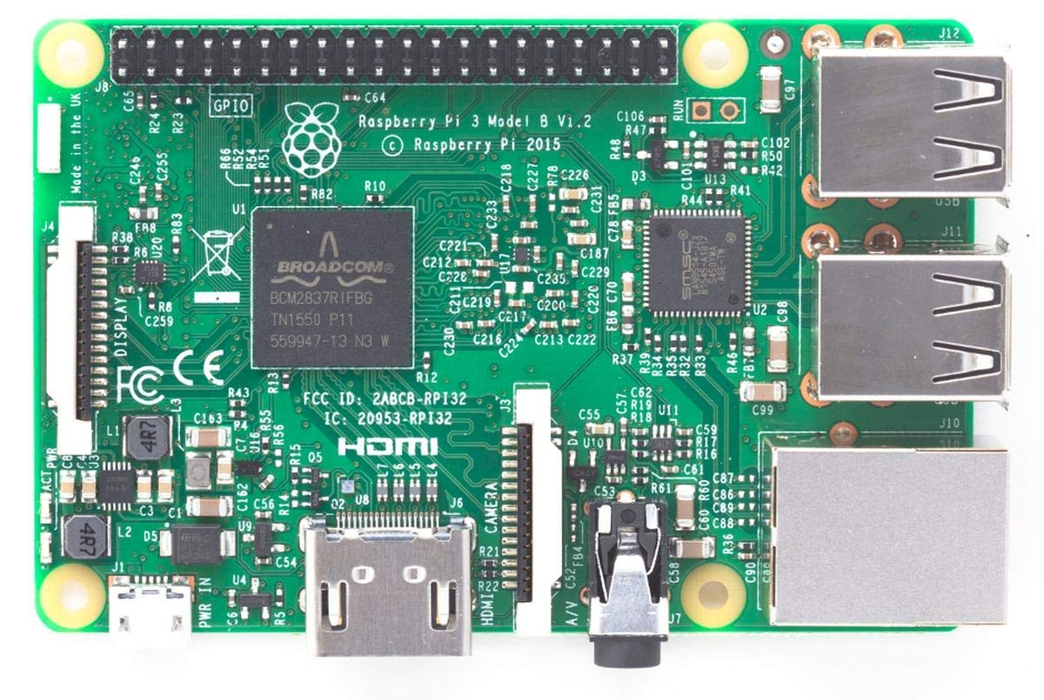

#### Fig 3.211 Raspberry Pi 3

### 

#### Fig 3.212 Raspberry Pi 3 Pinout

It contains 4 UARTs which are used as hardware serial ports, an ICSP header, a 16MHz crystal oscillator, a power jack, a USB connection port, and a reset button. Both an external power supply and a USB connection are available for powering the Arduino Mega. The power source is automatically chosen. It acts as the controller of the system as it controls the entire system and stores the program in it. Signals from the PIR sensor are given to the microcontroller. It receives information from the sensor and sends this information to the web page using the ESP-8266 wi-fi module.

### 3.22 Arducam Camera

The Arducam 5 Megapixels 1080p Sensor OV5647 Mini Camera Module for Raspberry Pi is a compact and powerful imaging solution tailored specifically for Raspberry Pi enthusiasts and developers. At its core lies the OV5647 sensor, boasting a 5-megapixel resolution that delivers crisp and detailed images at a resolution of 2592x1944 pixels. This sensor excels not only in image capture but also in video recording, supporting Full HD 1080p video at a smooth 30 frames per second, ensuring high-quality video footage. One of its notable features is the wide-angle lens, offering a broader field of view for versatile application across various projects and scenarios. It seamlessly connects to Raspberry Pi models through the CSI (Camera Serial Interface) port, providing a straightforward integration process

#### Specifications:

* Sensor: OV5647 5-megapixel sensor
* Resolution: Capable of capturing images at 2592x1944 pixels
* Video Resolution: Supports 1080p Full HD video recording at 30 fps
* Lens: Wide-angle lens providing a broader field of view
* Interface: Connects via the Raspberry Pi's CSI (Camera Serial Interface) port
* Dimensions: Compact and small form factor suitable for embedded projects
* Weight: Lightweight design for easy integration into various applications

## 

## 

#### Fig 3.221 Arducam Camera

### 3.23 BLDC Motor

A Brushless DC (BLDC) motor, unlike its traditional DC counterpart, operates without brushes for commutation, enhancing its reliability and reducing wear and tear. This motor converts electrical energy into mechanical energy by creating a rotating magnetic field within its stator, powered by a direct current source. The absence of brushes simplifies the design and minimizes maintenance, leading to increased efficiency and longevity.The operation of a BLDC motor involves electronic commutation through an external controller or an integrated drive. Sensors or electronic feedback mechanisms determine the rotor's position, allowing precise control over speed and torque. This precise control is particularly advantageous in industrial applications where accuracy and consistent performance are critical.The unique characteristics of BLDC motors make them favorable in applications demanding controlled and efficient operations. Their ability to swiftly start, stop, and reverse direction, coupled with their inherent efficiency and reliability, positions BLDC motors as valuable components in robotics, automotive systems, and various industrial machinery."BLDC motors offer advantages like higher efficiency, reduced maintenance due to the absence of brushes, and precise speed control, making them a preferred choice in applications that demand reliability and accuracy in motor performance

#### Specifications:

* Operating Voltage(V): 12
* Rated Speed (RPM): 1000KV
* Rated Torque(kg-cm): 1.5
* Stall Torque(kg-cm): 5.4
* Load Current (A): 0.3
* No Load Current (A): 0.06

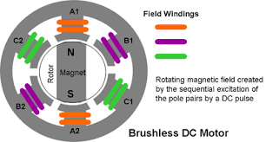

#### **Fig 3.**231 **BLDC Motor**

#### Working:

A Brushless DC (BLDC) motor operates through a sophisticated interplay of magnetic fields and electronic control. Its fundamental design consists of a stationary stator housing copper windings and a rotating rotor embedded with permanent magnets. Unlike traditional motors, BLDC motors forgo brushes and rely on an external controller or driver for precise commutation. This electronic control orchestrates the power delivery to the stator coils in a specific sequence, creating a rotating magnetic field that interacts with the fixed magnets on the rotor. Crucial to its operation is the detection of rotor position, achieved either through dedicated sensors or sensorless methods relying on the back electromotive force (EMF) generated in the coils. Based on this information, the controller orchestrates the sequential activation of the stator coils, a process known as commutation, ensuring precise synchronization between the rotating magnetic field and the rotor's permanent magnets. The harmonious interplay of these components results in smooth, efficient, and precise motor operation. BLDC motors find extensive application in diverse industries due to their efficiency, low maintenance, and precise speed control capabilities, serving in electric vehicles, robotics, home appliances, and industrial machinery where reliable, variable-speed performance is essential.

### 3.24 ESC simonK 30A

The ESC SimonK 30A refers to an Electronic Speed Controller designed for brushless motors in remote-controlled vehicles, specifically favored in multirotor aircraft like drones. This component plays a vital role in regulating the speed and direction of brushless motors by interpreting signals from the flight controller. What distinguishes the ESC SimonK 30A is its utilization of SimonK firmware, a specialized software known for optimizing ESC performance. This firmware offers faster response times, smoother motor operation, and improved throttle response compared to standard firmware. The "30A" rating signifies its ability to handle a maximum continuous current of 30 amps, a crucial aspect determining its compatibility with various motor sizes and its capacity to manage power without overheating. These ESCs find widespread use in multirotor aircraft due to their compatibility with different flight controllers and their ability to deliver reliable, responsive motor control, enhancing the overall performance of RC drones and similar applications.

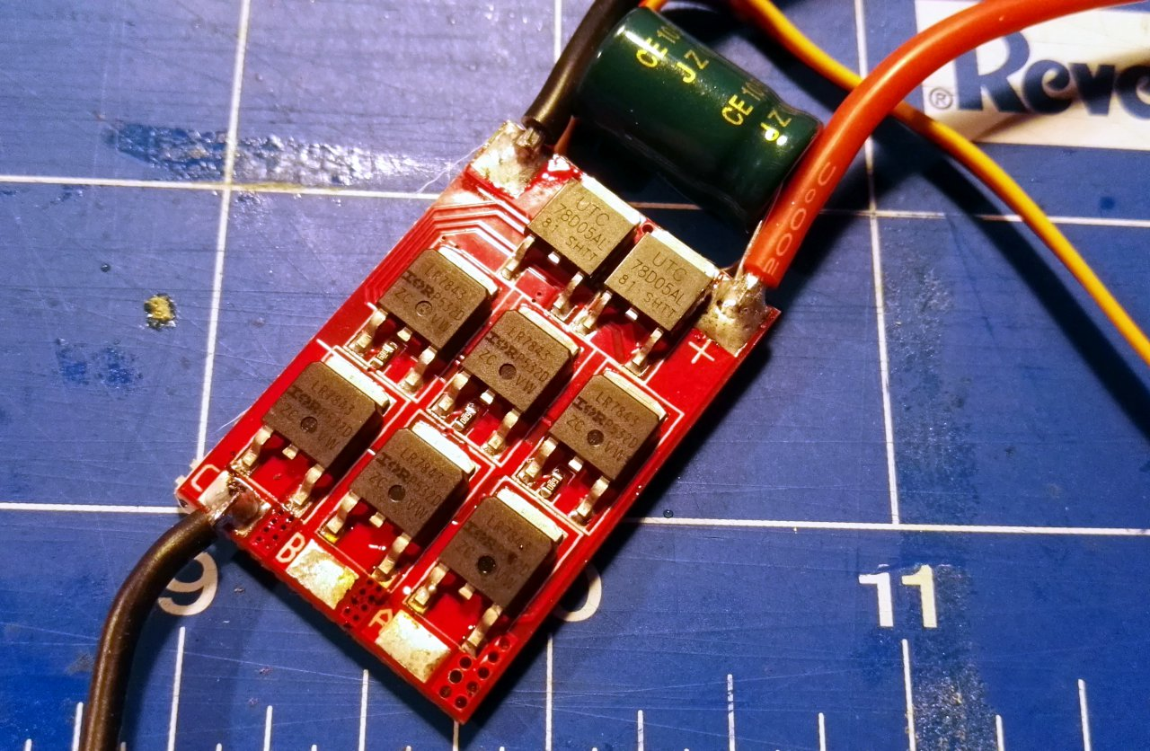

#### Fig 3.241 ESC simonK 30A

#### Specifications:

* Current Rating: 30A
* Voltage Range: 7.4V to 14.8V.
* Firmware: SimonK firmware
* Overcurrent protection,
* temperature protection
* voltage cutoff protection

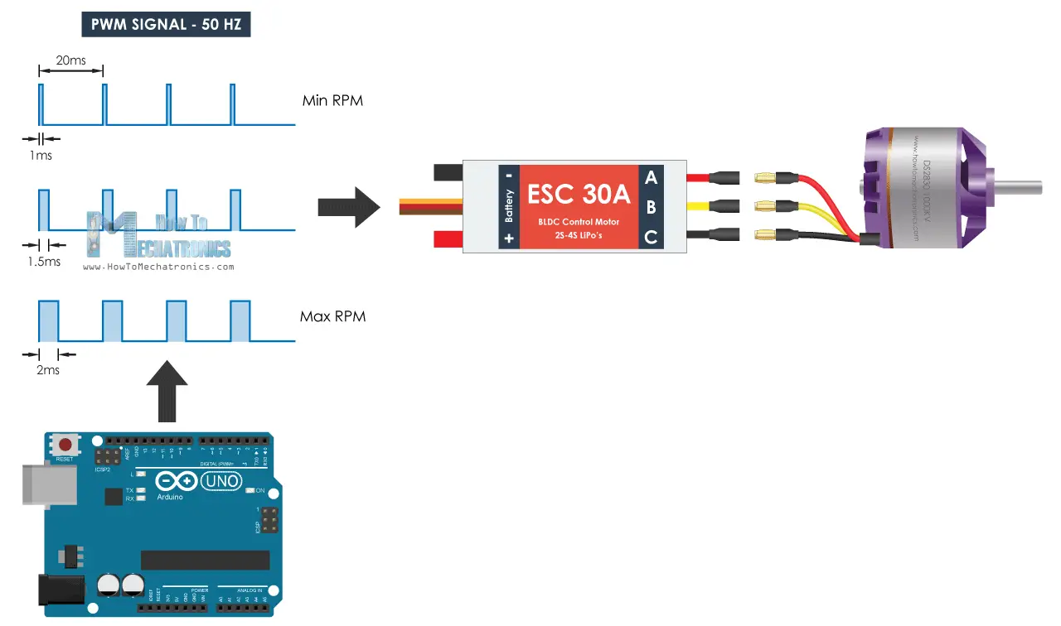

#### Fig 3.242 ESC Wire Configuration

#### ESC Wire Configuration:

Positive (+) Wire: Connects to the positive terminal of the LiPo battery

Negative (-) Wire: Connects to the negative terminal of the LiPo battery

Signal Wire: Carries control signals from the flight controller to the ESC, controlling the motor's speed and direction based on the flight controller's instructions.

U Phase: Connects to phase 1 of the motor.

V Phase: Connects to the second phase of the motor.

W Phase: Connects to the third phase of the motor.

| **Wire No** | **Wire Name** | **Description** |
| --- | --- | --- |
| 1 | Black | Ground wire connected to the ground of system |
| 2 | Red | Powers the motor typically +5V is used |
| 3 | Orange | Carries control signals from the flight controller to the ESC |
| 4 | RED | Connects to phase 1 of the motor. |
| 5 | YELLOW | Connects to the second phase of the motor. |
| 6 | BLACK | Connects to the third phase of the motor. |

#### 

#### Table 3.1 Wire Configuration of ESC

The ESC SimonK 30A, an Electronic Speed Controller, regulates brushless motor operation in RC vehicles, offering precise control over speed and direction. Unlike servo motors that incorporate a closed-loop mechanism with positional feedback, the ESC SimonK 30A relies on electronic commutation for motor control. It operates by interpreting signals from the flight controller and managing the power supplied to the brushless motor. The ESC SimonK 30A comprises input terminals for connecting to the power source, often a LiPo battery, and output terminals for connecting to the brushless motor. These terminals enable the ESC to regulate the motor's speed and direction based on the signals received from the flight controller. The firmware, specifically the SimonK firmware, enhances performance by providing faster response times and smoother throttle response compared to stock firmware. The wiring configuration of the ESC SimonK 30A typically consists of three wires - a positive (red) wire connected to the power supply (battery), a negative (black) wire connected to the ground, and a signal (usually white or yellow) wire connected to the flight controller or control unit. These wires enable communication and power supply for effective motor control and operation

**ESC Working Mechanism:**

An ESC, such as the SimonK 30A, operates as part of a closed-loop control system, using feedback to regulate motion and the final position of the motor. This device controls the brushless motor's speed and direction by comparing the output signal with a reference input signal, generating a feedback signal that determines the motor's behavior.In a closed-loop system, the ESC uses a positive feedback mechanism where the reference input signal is compared to the reference output signal. A feedback signal is generated as a result, serving as an input signal to control the device. This signal persists as long as there's a difference between the reference input and output signals, allowing the ESC to maintain the motor's output at the desired value, even in the presence of external disturbances or noise.

Interfacing with ESCs, like the SimonK 30A, is typically straightforward, involving three wires - a positive wire connected to the power supply, a negative wire for the ground, and a signal wire interfacing with the flight controller or control unit.ESC control is achieved using Pulse Width Modulation (PWM), where the duration of pulses sent through the control wire determines the motor's speed and direction. Similar to servo motors, ESCs expect pulses at a specific repetition rate (typically 20 milliseconds). Varying the pulse duration between minimum and maximum values controls the motor's speed and direction, allowing it to operate smoothly. The ESC SimonK 30A is specifically designed for brushless motors in RC vehicles, enhancing motor control and performance. Just as with servo motors, ensuring appropriate power supply and current management is crucial when utilizing multiple ESCs in an RC setup

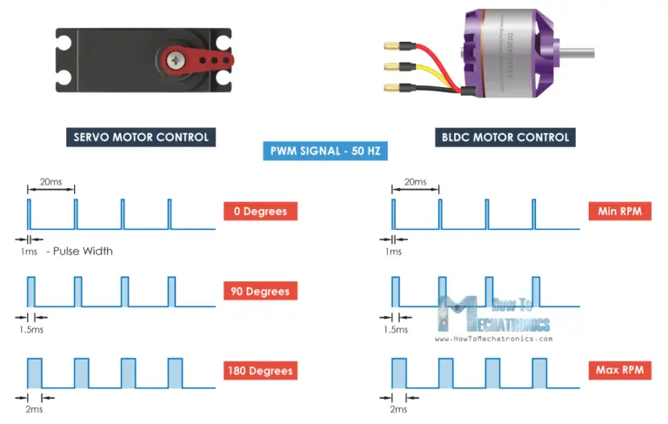

#### Fig 3.243 OUTPUT OF ESC

### 3.25 Flight controller Multiwii cruise SE 2.5

The Multiwii Cruise SE 2.5 flight controller firmware enhances stability and flight performance for multirotor aerial platforms like quadcopters and hexacopters. It achieves this by utilizing onboard sensors for accurate orientation and motion sensing, allowing users to adjust settings and PID parameters for fine-tuning flight characteristics. While known for its stability algorithms and ease of setup, this firmware has seen limited development compared to more modern options like Betaflight or Cleanflight, which offer advanced features and ongoing support. The Multiwii Cruise SE 2.5 firmware stands as a testament to the evolution of drone control technologies. It integrates sophisticated stability algorithms and sensor mechanisms to bolster stability and precision during flight operations.

#### Stability Algorithms

The firmware employs cutting-edge stability algorithms that harness the data from onboard sensors such as gyroscopes and accelerometers. This data ensures precise orientation and motion sensing, contributing significantly to stability during flight.

#### Flight Modes

With support for diverse flight modes, pilots can seamlessly transition between stability-centric modes for aerial photography or exploration and dynamic modes for acrobatic maneuvers, all while enjoying GPS-assisted navigation for precise location-based operations.

#### Configurability and Fine-Tuning

The interface enables users to modify PID parameters, enhancing or tempering the drone's responsiveness and stability, thereby adapting to various flying conditions and configurations.

#### Development and Legacy

While historically significant, the Multiwii Cruise SE 2.5 firmware has seen limited development in recent times. Newer firmware options like Betaflight and Cleanflight provide advanced functionalities, ongoing support, and superior performance, making them attractive alternatives for modern drone enthusiasts.

### 3.26 Li-Po battery pack

A 12V LiPo (Lithium Polymer) battery pack with a BMS (Battery Management System) is the setup in our application the 12V LiPo battery pack with a BMS provides a reliable power source for the drone, ensuring safety, longevity, and optimal performance when properly managed and used within its specified operating conditions.



#### Fig 3.261 Lipo battery pack

#### Specifications:

* Voltage: 12.6V (Fully charged) - 11.1V (Nominal voltage)
* Capacity: 3000 (mAh)
* Chemistry: Lithium Polymer (LiPo)
* Configuration: 3S
* Overcharge protection
* Over-discharge protection
* Short circuit protection
* Temperature monitoring and protection
* Connector Type: XT60.
* Size and Weight: 15 cm x 5cm

# CHAPTER IV

# SOFTWARE IMPLEMENTATION

## 4.1 NodeJS

**4.11 Base station**

##### User Authentication :

User authentication is a crucial aspect of application security, ensuring that individuals accessing a system are who they claim to be. It involves validating users' identities through credentials like usernames, email addresses, and passwords. The process begins with user registration, where individuals create accounts by providing unique credentials. To protect sensitive information, passwords are encrypted and stored securely in a database, usually hashed to prevent unauthorized access even if the database is compromised. Upon login, authentication mechanisms verify the provided credentials against stored records. Techniques like salted hashing and encryption algorithms validate passwords without storing them in plaintext. Various authentication methods exist, including token-based authentication like JSON Web Tokens (JWT) or session-based authentication using cookies. JWT tokens, for instance, contain encoded user information, providing secure and stateless authentication by verifying each request's authenticity.

##### User Registration:

Allow users to register by providing necessary details and credentials. Store this user information securely in your database (MySQL) and ensure password encryption for security.

##### Restrict Access to Video Footage:

When the base station server receives a request for video footage, it verifies the user's authentication status and permissions before providing access. If the user is authenticated and authorized, the server retrieves and streams the video footage to the user interface. Otherwise, it denies access or displays an error message.

## 4.2 React JS

##### User Login Page:

This page allows users to log in using their credentials (such as username and password) via a secure authentication process.Once authenticated, users gain access to functionalities like sending SOS signals or distress requests.

##### Authorized Personnel Dashboard:

This dashboard is accessible only to authorized personnel (e.g., police officers) after successful login. It displays a list of SOS requests made by users, showing relevant details such as location, time, and urgency level. Additionally, it provides access to view recorded drone footage associated with SOS requests.

##### Login Page Components:

Create components for user authentication, including login form fields, authentication logic, and error handling. Use state management (such as React's useState or Redux) to handle user login status and session management.

Authorized Personnel Dashboard: Develop components for the dashboard, displaying SOS requests and associated details fetched from the server. Implement functionalities to fetch and display recorded drone footage linked to each SOS request.

##### API Integration:

Utilize APIs (RESTful or GraphQL) to interact with the backend server for user authentication, SOS signal submission, fetching SOS requests, and retrieving drone footage data.

##### Conditional Rendering:

Implement conditional rendering in React components to display different views based on user roles. For instance, show the login page for unauthenticated users and the dashboard for authorized personnel.

Ensuring security in data transmission and access control is crucial. Implement secure authentication methods and role-based authorization to restrict access to sensitive functionalities and data.

## 4.3 Mysql

The users table stores user authentication and profile information. The sos_requests table stores SOS request details linked to users via a foreign key relationship (user_id). It also includes a field (video_path) referencing the location or path of the associated video footage stored in the base station's storage. When users send SOS signals, entries are added to the sos_requests table, associating each request with a specific user and potentially linking to the corresponding video footage location.

##### User Data Table:

This table stores information about registered users, including usernames, passwords (hashed for security), email addresses, and any other relevant user information. Each user is typically identified by a unique identifier (ID) or username, and their information is stored in separate rows within this table.

##### Request & Video Footage Table:

This table is used to store SOS requests and links to video footage stored in the base station's storage. It contains information about each SOS request, such as location, time, urgency level, and possibly a reference or path to the corresponding video footage stored in the base station's storage.

## 4.4 Python

##### SOS Request:

The Python script will be triggered for incoming SOS requests from the rpi server. These requests contain GPS coordinates indicating the location requiring assistance.

##### Drone Navigation:

Upon receiving the SOS request, the script utilizes the GPS coordinates as arguments to calculate the drone's navigation path.It uses drone control libraries to send navigation commands to the UAV, instructing it to fly to the specified location.

##### Capturing Video Footage:

As the drone navigates to the location, the Python script triggers the drone's camera to start recording video footage of the area.

##### Transmission to Base Station:

Once the drone reaches the designated location or completes its surveillance, the script initiates the transfer of recorded video footage to the base station.This transfer could involve encoding the video data and sending it over a network connection to the base station's server or storage.

##### Error Handling & Confirmation:

The script includes error handling mechanisms to account for any issues during navigation or video transmission. It provides confirmation or status updates to the base station upon successful completion of the task or in case of any errors encountered during the process.

##### Security Measures:

Encryption and secure transfer protocol https is used when sending sensitive video data to the base station to prevent unauthorized access or interception.

## 4.5 Flow chart

# CHAPTER V

# PROPOSED METHODOLOGY

This model uses a Raspberry Pi 3 for environmental monitoring and begins with a comprehensive analysis of project requirements, outlining the scope and necessary functionalities crucial for data collection. Hardware setup involves acquiring the Raspberry Pi 3 and relevant peripherals, connecting sensors, and ensuring stable power supply and grounding. Subsequently, software configuration entails setting up the Pi with an appropriate operating system, installing essential libraries for sensor interfacing, and developing or employing code for data acquisition and processing. Emphasis lies on meticulous data collection, processing, and storage, followed by visualization tools creation for easy data interpretation. Networking configurations are essential, ensuring remote access and secure monitoring capabilities.Thorough documentation encompassing setup instructions and troubleshooting guides concludes the project, with room for iterative improvements based on feedback and ongoing evaluations, enhancing system performance and functionalityThe utilization of a Raspberry Pi 3 for environmental monitoring epitomizes a meticulous approach to harnessing technology for data collection and analysis.

This venture embarks on a journey rooted in a comprehensive analysis of project prerequisites, methodically outlining the scope and requisite functionalities pivotal for gathering pertinent data. At the core of this undertaking lies the hardware setup, an intricate process that commences with the acquisition of the Raspberry Pi 3 alongside its complementary peripherals. Ensuring a seamless integration, sensors pertinent to environmental metrics are methodically connected, meticulously tested to ensure precision, and secured within the setup, while due diligence is observed in guaranteeing a stable power supply and establishing a robust grounding system to mitigate potential risks.

The subsequent phase gracefully transitions to the realm of software configuration, a pivotal facet encapsulating the essence of the project. Here, the Raspberry Pi is ushered into functionality through the installation of an appropriate operating system, meticulously chosen to align with the project's requisites. Essential libraries, crucial for interfacing with the diverse array of sensors, are meticulously installed, setting the stage for data acquisition and processing. Whether through the creation of custom code tailored to the project's demands or the adept employment of existing solutions, the focus remains steadfast on extracting and processing data with precision and efficiency.

The nucleus of this endeavor revolves around the judicious collection, intricate processing, and secure storage of voluminous data. Rigorous attention is bestowed upon devising mechanisms that not only gather data comprehensively but also ensure its accuracy and reliability. This rich repository of environmental data finds fruition through the creation of intuitive visualization tools, facilitating lucid interpretation and analysis for stakeholders. The potency of these visual aids lies in their ability to distill complex datasets into easily digestible insights, empowering informed decision-making and fostering a deeper comprehension of environmental dynamics.

Networking configurations form the sinews binding this system, laying the foundation for remote access and fortified monitoring capabilities. The meticulous setup of networking protocols and security measures ensures a seamless avenue for remote oversight without compromising on data integrity or system security. The culmination of this ambitious project transcends its technical facets as a comprehensive documentation compendium comes to fruition. This documentation, a testament to meticulous detailing, encompasses comprehensive setup instructions and adeptly crafted troubleshooting guides, serving as a beacon for system administrators and stakeholders navigating the intricacies of this technological marvel.

The denouement, however, is merely a prelude to an era of iterative enhancements. Feedback channels and ongoing evaluations are embraced as catalysts for perpetual refinement, an avenue to elevate system performance and augment functionalities based on real-world usage and evolving needs. This project encapsulates the epitome of technological synergy, fusing hardware, software, and meticulous planning to create an ecosystem fostering deeper insights into our environment while charting a path towards sustainable progress.

# CHAPTER VI

# RESULTS AND DISCUSSION

## Operational Efficiency of SOS Response:

Upon SOS activation, the drone swiftly navigated to the designated location, demonstrating efficient flight operations facilitated by the Raspberry Pi-based control system. The system's responsiveness to SOS triggers ensured timely aerial surveillance for incident response.

## Seamless Video Recording and Transmission:

The drone seamlessly initiated video recording upon reaching the location, capturing comprehensive footage of the area. The subsequent transmission of recorded video to the base station was achieved with minimal latency, ensuring swift data transfer for further analysis.

## Security and Access Control:

Access controls limited video viewing privileges to authorized personnel, specifically law enforcement officials. This restricted access ensures data integrity and confidentiality, allowing only authenticated users to access and analyze the recorded footage.

## Crime Analysis and Decision-Making:

Law enforcement officials leveraged the recorded drone footage to discern potential criminal activity within the monitored area. The high-resolution video aided in identifying and evaluating suspicious behavior or incidents, facilitating informed decision-making for subsequent actions.

## Challenges and Mitigations:

Challenges, such as occasional connectivity disruptions during video transmission and limited drone battery life affecting prolonged surveillance, were addressed through iterative improvements in networking protocols and battery optimization strategies.

# CHAPTER VII

## 7. CONCLUSION

The proposed system's objective in a disaster area is to deliver an efficient and accessible means of surveying and assessing affected areas. Equipped with advanced imaging and live-streaming capabilities, this UAV is tailored to swiftly provide critical visual data to response teams. Utilizing high-resolution cameras and live-streaming technology, this UAV becomes a vital tool for surveying crime prone regions. Its real-time transmission capabilities enable immediate access to crucial information, aiding in the identification of affected areas and potential suspects. The incorporation of robust communication modules, such as 4G networks, ensures seamless data transmission, allowing multiple stakeholders to access live feeds and coordinate response efforts. This UAV system stands as a cost-effective, user-friendly, and agile solution for disaster response teams. Its ability to cover expansive regions efficiently, stream live footage, and relay information in real-time positions it as a valuable asset in optimizing search and rescue operations, ultimately contributing to the swift and effective management of disaster scenarios.

# REFERENCES

1. Y. Pan, Q. Chen, N. Zhang, Z. Li, T. Zhu and Q. Han, "Extending Delivery Range and Decelerating Battery Aging of Logistics UAVs Using Public Buses," in IEEE Transactions on Mobile Computing, vol. 22, no. 9, pp. 5280-5295, 1 Sep. 2023, doi: 10.1109/TMC.2022.3167040.
2. Y. Qin, M. A. Kishk and M. -S. Alouini, "Stochastic-Geometry-Based Analysis of Multipurpose UAVs for Package and Data Delivery," in IEEE Internet of Things Journal, vol. 10, no. 5, pp. 4664-4676, 1 March 1, 2023, doi: 10.1109/JIOT.2022.3218674.
3. J. Yoon, A. -H. Lee and H. Lee, "Rendezvous: Opportunistic Data Delivery to Mobile Users by UAVs Through Target Trajectory Prediction," in IEEE Transactions on Vehicular Technology, vol. 69, no. 2, pp. 2230-2245, Feb. 2020, doi: 10.1109/TVT.2019.2962391.
4. J. Xu, K. Ota and M. Dong, "Big Data on the Fly: UAV-Mounted Mobile Edge Computing for Disaster Management," in IEEE Transactions on Network Science and Engineering, vol. 7, no. 4, pp. 2620-2630, 1 Oct.-Dec. 2020, doi: 10.1109/TNSE.2020.3016569.
5. K. G. Panda, S. Das, D. Sen and W. Arif, "Design and Deployment of UAV-Aided Post-Disaster Emergency Network," in IEEE Access, vol. 7, pp. 102985-102999, 2019, doi: 10.1109/ACCESS.2019.2931539.
6. M. Aljehani and M. Inoue, "Performance Evaluation of Multi-UAV System in Post-Disaster Application: Validated by HITL Simulator," in IEEE Access, vol. 7, pp. 64386-64400, 2019, doi: 10.1109/ACCESS.2019.2917070.
7. J. P. Matos-Carvalho, R. Santos, S. Tomic and M. Beko, "GTRS-Based Algorithm for UAV Navigation in Indoor Environments Employing Range Measurements and Odometry," in IEEE Access, vol. 9, pp. 89120-89132, 2021, doi: 10.1109/ACCESS.2021.3089900.
8. Y. Zeng, X. Xu, S. Jin and R. Zhang, "Simultaneous Navigation and Radio Mapping for Cellular-Connected UAV With Deep Reinforcement Learning," in IEEE Transactions on Wireless Communications, vol. 20, no. 7, pp. 4205-4220, July 2021, doi: 10.1109/TWC.2021.3056573.
9. S. Zahran, A. M. Moussa, A. B. Sesay and N. El-Sheimy, "A New Velocity Meter Based on Hall Effect Sensors for UAV Indoor Navigation," in IEEE Sensors Journal, vol. 19, no. 8, pp. 3067-3076, 15 April 15, 2019, doi: 10.1109/JSEN.2018.2890094.